Java Lambda Expressions
import java.io.*;
import java.util.*;
interface PerformOperation {
boolean check(int a);
}
class MyMath {
public static boolean checker(PerformOperation p, int num) {
return p.check(num);
}
PerformOperation isOdd() {
return n -> n % 2 != 0;
}
PerformOperation isPrime() {
return n -> {
if (n < 2) return false;
for (int i = 2; i * i <= n; i++) {
if (n % i == 0)
return false;
}
return true;
};
}
PerformOperation isPalindrome() {
return n -> {
int temp = n, rev = 0;
while (temp > 0) {
rev = rev * 10 + temp % 10;
temp /= 10;
}
return rev == n;
};
}
}
public class Solution {
public static void main(String[] args) throws IOException {
MyMath ob = new MyMath();
BufferedReader br = new BufferedReader(new InputStreamReader(System.in));
int T = Integer.parseInt(br.readLine());
PerformOperation op;
boolean ret = false;
String ans = null;
while (T--> 0) {
String s = br.readLine().trim();
StringTokenizer st = new StringTokenizer(s);
int ch = Integer.parseInt(st.nextToken());
int num = Integer.parseInt(st.nextToken());
if (ch == 1) {
op = ob.isOdd();
ret = ob.checker(op, num);
ans = (ret) ? "ODD" : "EVEN";
} else if (ch == 2) {
op = ob.isPrime();
ret = ob.checker(op, num);
ans = (ret) ? "PRIME" : "COMPOSITE";
} else if (ch == 3) {
op = ob.isPalindrome();
ret = ob.checker(op, num);
ans = (ret) ? "PALINDROME" : "NOT PALINDROME";
}
System.out.println(ans);
}
}
}

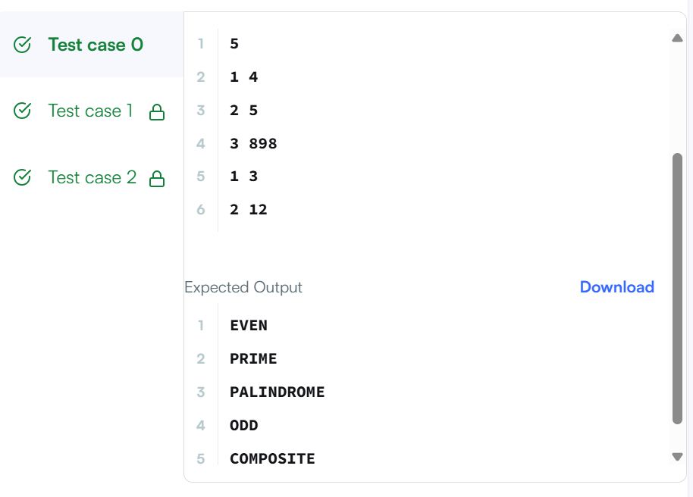

import java.util.*;
class Checker implements Comparator<Player> {
public int compare(Player a, Player b) {
if (a.score != b.score) {
return b.score - a.score;
}
return a.name.compareTo(b.name);
}
}
class Player{
String name;
int score;
Player(String name, int score){
this.name = name;
this.score = score;
}
}
class Solution {
public static void main(String[] args) {
Scanner scan = new Scanner(System.in);
int n = scan.nextInt();
Player[] player = new Player[n];
Checker checker = new Checker();
for(int i = 0; i < n; i++){
player[i] = new Player(scan.next(), scan.nextInt());
}
scan.close();
Arrays.sort(player, checker);
for(int i = 0; i < player.length; i++){
System.out.printf("%s %s\n", player[i].name, player[i].score);
}
}
}

